How to Setup Static IP Mode
This article will guide you how to setup Dynamic IP / DHCP mode and the steps as below.
Model Number: N301/F3/FH456 Question Classification: Internet Settings

Note: If you have no idea about what is the connection type of your network, please contact the ISP (Internet service provider) to confirm it.
Part 1: Connect the devices
Part 2: Configure your computer
Part 3: Setup the router
Part 4: Check whether you can access internet

1.Connect the broadband line to the WAN port of router, and then connect your computer to LAN1/LAN2/LAN3 port by a cable. Physical connection as bellow:
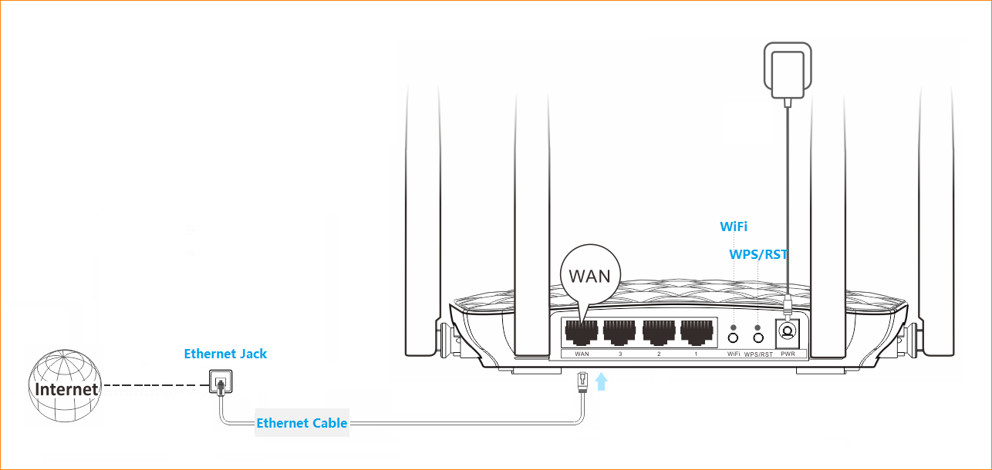
1. Right click Network Connection Icon on the system bar, then click on Open Network and Sharing Center.
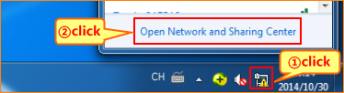
2. Click on Change Adapter Settings.
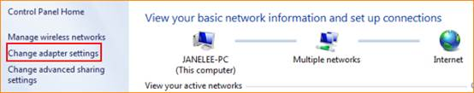
3. Right click on Local Area Connection, then choose the Properties option.
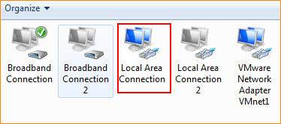
4. Double click on Internet Protocol Version 4(TCP/IPv4).
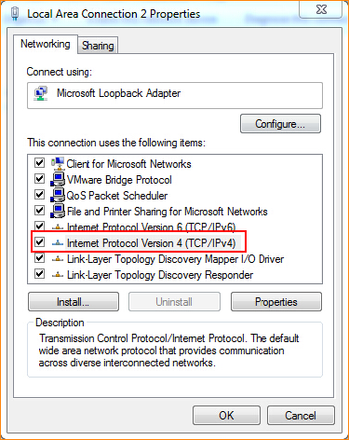
5. Choose Obtain an IP address automatically and Obtain DNS server address automatically and then click OK.

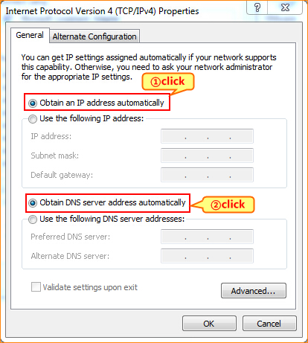
6 Also click OK an the last window of Local Connection Properties.
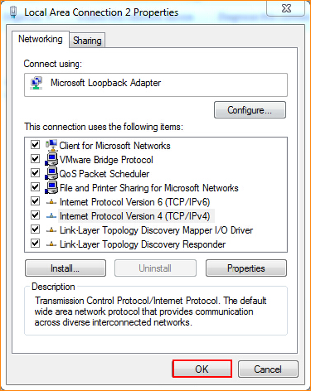
- Open a browser then type 192.168.0.1 into the Address Bar, press Enter. And go to the homepage of the router.
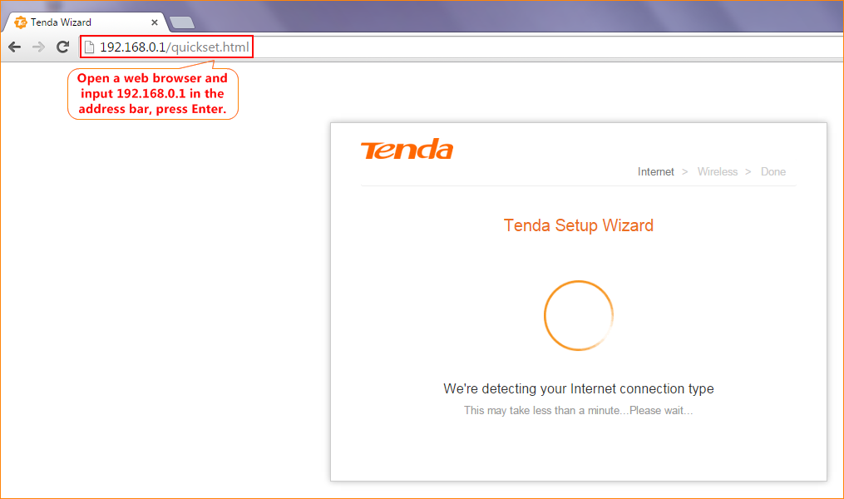
2. Router will recognize your internet connection type as “Static IP”, Type the static IP, subnet mask, default gateway, and preferred DNS server provided by your Internet Service Provider. and click Next.
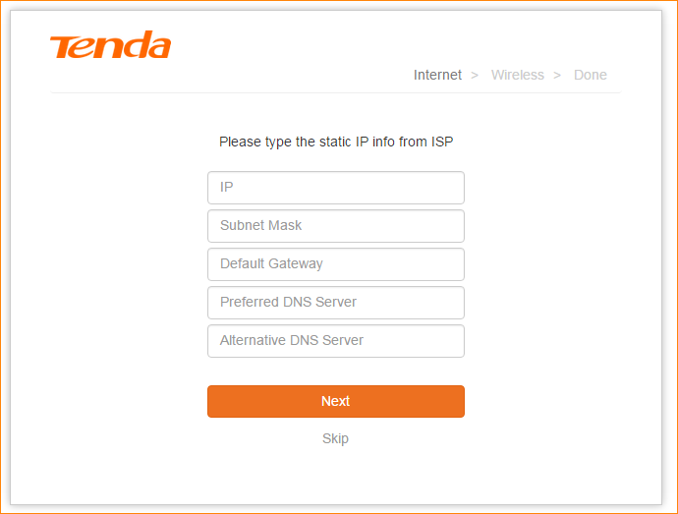
3. Setup the name and password of your WIFI signal. Click “Next”. The reference as bellow.
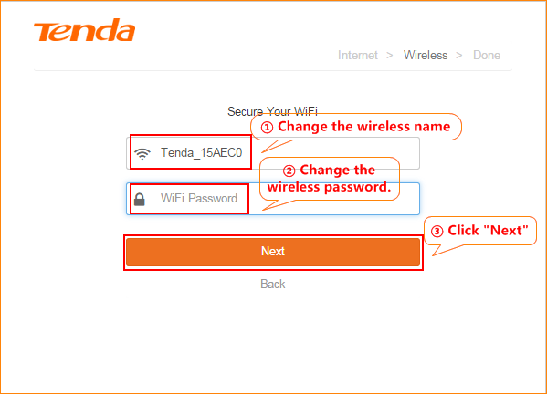
4. “Saving… please wait…” Wait about 10 seconds, it will come out an interface.
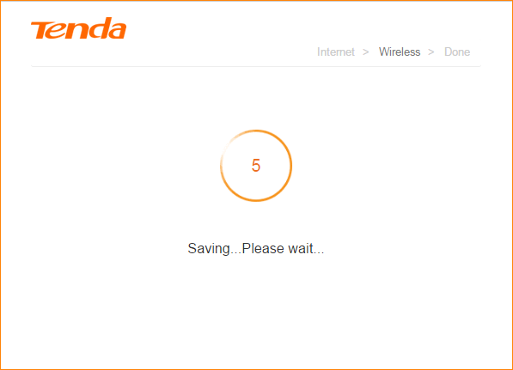
5. When the following page appears, it indicates that you can access the Internet now. If you want to experience more features, click More to log in to the Router’s user Interface.
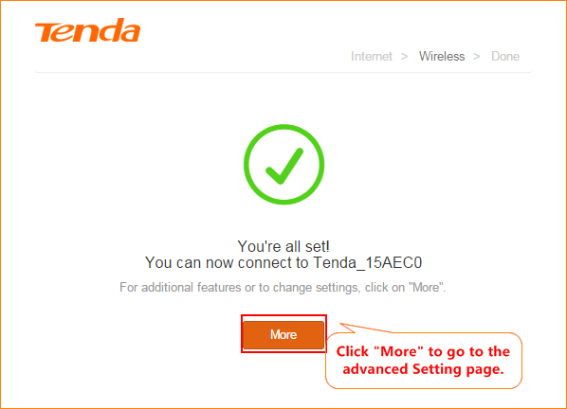
6. In router’s setup page, click “Status.” Check connection status.
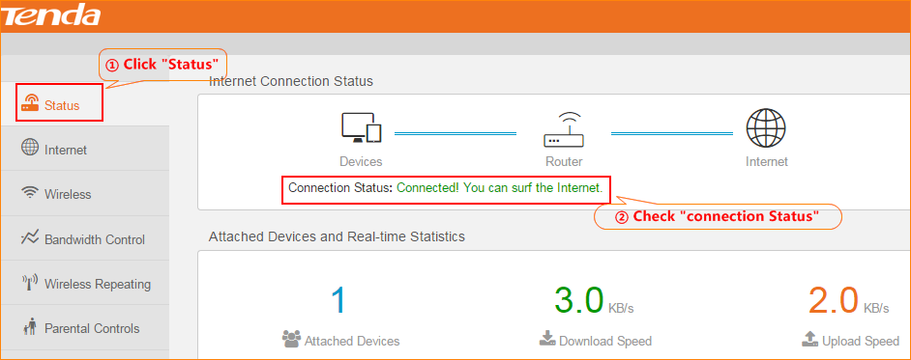

Login to the advanced setting page, then check “Status” if shows “Connected! You can surf the Internet ” that means you can access internet.

NOTE:
When the Connection Status Show Connecting, please try the steps as below.
1. Click Adminostration→WAN Parameters→Clone MAC.
Some ISPs will bind your broadband account info and a specified MAC address of your computer together. If you can only access the Internet with a specified computer without a Router, you can try cloning MAC address for normal Internet access. By default, it clones the factory MAC address (the MAC address of the router). If you want to clone the MAC address of the current attached computer, select Clone Local Host’s MAC and click OK on the bottom of the page.

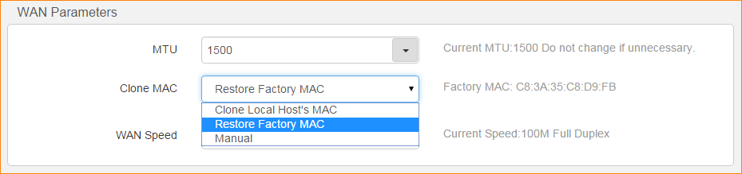

2. In WAN Parameters, pelase choose WAN Speed in the drop-menu. Then click OK to save the settings.
By default, the WAN rate is Auto. Generally, it is not advisable to change the default value. When the cable length between your Router and the remote device (modem, Router, etc.) is relatively long, you can set WAN rate to 10M FDX or 10MHDX to enhance transmission rate.
