MW6- Set up “Tenda WiFi” skill on Amazon echo
The document applies to users who want to use “Tenda WiFi” skill on amazon echo
Step 1: Go to the “All Skills” page
1.1 Open the Alexa app, sign in your Amazon account. Then tap “Home”.
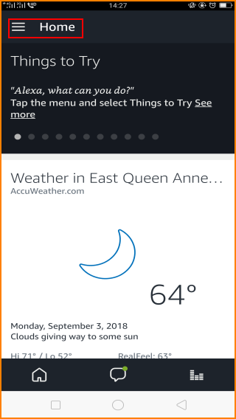
1.2 Then tap “Skills”
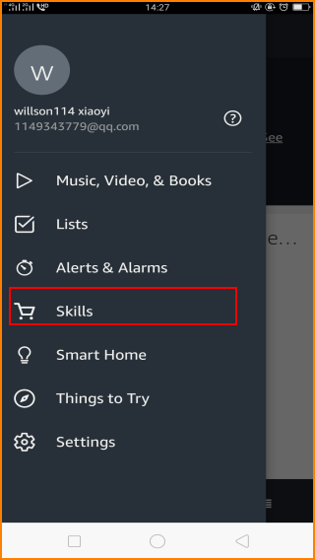
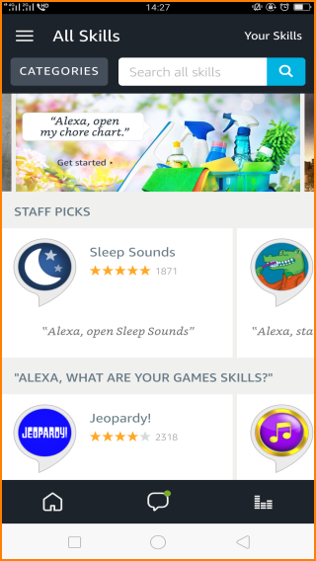
Step 2:
2.1 To use Tenda skills. Input “Tenda” in the Search bar and search for "Tenda WiFi". Then tap “Tenda WiFi”.
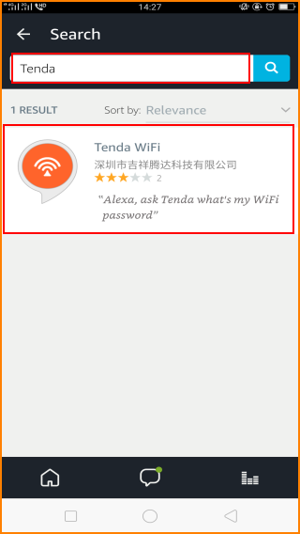
2.2 Tap “ENABLE”, Approve requested access from the Skill Permissions page, then tap “SAVE PERMISSIONS”.
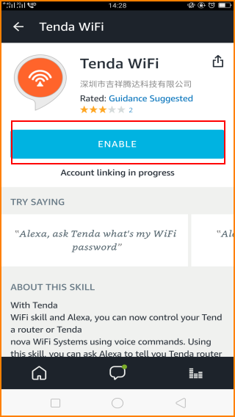
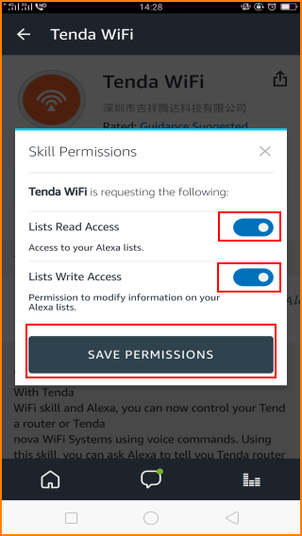
2.3 Then the phone will pop up this page, input your Email for applying for a Tenda account and your password.
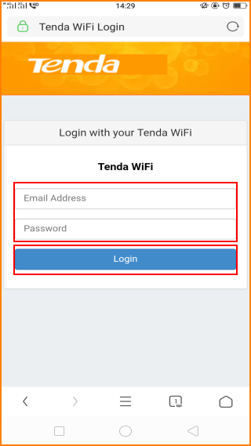
2.4 Waiting for a few minutes, then Tenda WiFi has been successfully linked.
